Smart method for Gas Fee Optimization in NFT Marketplaces

Avaneesh Singh

*Department of Computer Science*, KIET Group of Institutions, Delhi-NCR, Ghaziabad

Harsh Kumar

*Department of Computer Science*, KIET Group of Institutions, Delhi-NCR, Ghaziabad

Nishant Varshney

*Department of Computer Science*, KIET Group of Institutions, Delhi-NCR, Ghaziabad

Harsh Khatter

*Department of Computer Science*, KIET Group of Institutions, Delhi-NCR, Ghaziabad

**Abstract -** The Non-Fungible Tokens (NFT) are digital assets that are unique and can be traded online using Cryptocurrencies that are generally encoded within the blockchain. These NFT’s can be digital artwork, collectibles, in-game items, pieces of code, etc. They provide a certificate of authenticity or ownership of a specific asset to its creator which can be transferred to others through the marketplace. It was first introduced in late 2017 on the Ethereum network. NFTs have created a new economic model for digital assets, allowing creators to monetize their work in ways that were not previously possible. Our efforts to create an NFT marketplace aimed to reduce the gas fees required to perform certain actions and an overall reduction of 14.7% was achieved.

**Keywords used - Non-Fungible Token (NFT), Blockchain, Ethereum, Smart Contracts, Gas Cost**

# INTRODUCTION

To get to know more about NFts we need to understand blockchain. It is a distributed database or a ledger that is shared in a computer network. Information stored in this database is digitally verified in a distributed manner. Cryptocurrencies such as Bitcoin and Ethereum are based on this blockchain technology for the creation and maintenance of decentralized records of transactions. This blockchain removes the dependency on any organization or network and provides security in a decentralized manner.

Another benefit of NFTs in art is that it allows for fractional ownership of artworks, meaning that a single piece of art can be owned by multiple people through NFTs, opening up the art market to a wider range of people who couldn't afford to own an original piece.

NFTs have also been adopted in the gaming industry as a way to create special, unique, collectible items that can be sold, bought, and traded like digital or physical assets. These NFTs can take the form of in-game items such as weapons, armor, and vehicles, as well as virtual land and other digital assets. One of the benefits of using NFTs in gaming is that they allow players to truly own and sell their in-game items, rather than just having temporary access to them. This creates a secondary market for in-game items, where players can buy and sell items for real money. Similarly, NFTs can be applied in various fields and can be utilized using a marketplace. There have been several high-profile NFT sales in recent years, with some of the most popular and expensive NFTs being digital artworks.In March 2021, the artist Beeple sold "Everyday: The First 5000 Days" for $69 million, setting a new record for the most expensive NFT ever sold. Other notable sales include "The Fabled Land" by Fvckrender for $6.6 million in December 2020, "Block 21" by Fewocious for $6.2 million in December 2020, "The First Supper" by Pak for $6.5 million in November 2020, and "CryptoPunk #7804," a pixelated image of a punk-looking character, which sold for $11.8 million in May 2021.

NFTs have several advantages and disadvantages. One of the benefits of NFTs is that they allow for true ownership and provenance of digital assets, as each NFT is unique and stored on the blockchain. Additionally, NFTs enable fractional ownership of artworks, making it possible for multiple people to own a single piece through NFTs. This opens up the market to a wider range of people who couldn't afford to own an original piece. NFTs also provide a new revenue stream for creators, such as artists, musicians, and game developers, who can sell NFTs of their work for much higher prices than traditional digital art.

On the other hand, the energy consumption associated with creating and trading NFTs can be significant, raising concerns about their environmental impact. There have also been instances of scam NFTs being sold, highlighting the lack of regulation in the market. Additionally, it can be challenging to determine the value of a digital artwork, leading to speculation and volatility in the market. Finally, not everyone has access to the technology or resources needed to create and trade NFTs, which can limit accessibility and inclusivity.

# LITERATURE REVIEW

In this section, we outline the various challenges and opportunities we discovered after analyzing various research papers on NFTs and their marketplace implementation. In the paper by Akhtar et al. [1], the authors highlight the findings of a study that examines the potential problems in the NFT ecosystem. The research found that in NFT trades, anonymous users execute transactions without any physical asset to be transported, which makes money laundering schemes easier. Additionally, there are no measures for implementing Anti-Money Laundering (AML) or Know Your Customer (KYC) rules and Combating the Financing of Terrorism (CFT) measures. This means tracing the user's identity and background becomes difficult. However, another issue that they identified is the lack of Two-Factor Authentication (2FA) in NFT marketplaces, with some marketplaces supporting 2FA but not enabling it by default which could result in security breaches. This issue of accidentally easing money laundering and fraud was also raised during the evolution of blockchain technologies and the rise of bitcoin. Various governments, in turn, introduced harsh regulations on its use going as far as banning the use of technology entirely. A brief look into the evolution of blockchain can help us understand how this issue was tackled. Muhammed Nasir's paper on the survey of blockchain and its evolution [2] refers to this subject matter. Blockchain 1.0 was the first application of the technology known as “ The origin of modern blockchain”. The first generation of blockchain technology also called the Inception of modern blockchain is the most reduced form of a ledger that is decentralized and writes down transactions while saving the data across several devices. Then came the era of Ethereum which allowed developers to write “Smart Contracts” which allowed code execution on the chain. This technology is crucial in understanding how NFTs and their marketplace can be implemented. This code execution and data modification require computation power which is quantified as a ‘gas’ fee. This cost can be a rising concern and is tackled in our implementation which we will discuss in the “NFT Marketplace Architecture” section.

NFT Certificates have the potential to play a significant role in the jewelry industry. It provides a unique way to establish authenticity and ownership of these unique pieces. The jewelry items are composed of premium-grade metals such as gold, silver, platinum, rubies, emeralds, etc. Generally, the authenticity of these metals is issued using paper-based certifications which are subject to counterfeiting, loss, or theft. When jewelers create a unique piece of jewelry such as a ring or necklace, an NFT certificate can be issued using blockchain which contains relevant information such as the design of jewelry, materials used, and purity of metal, which are superior in terms of traceability, immutability, verifiability, and security. A system design and architecture are proposed with a sequence of diagrams covering key aspects like production, purchase, and sale along with algorithms related to auctioning, NFT mining, ownership management, and delivery. The smart contracts and script are available as open source on GitHub involving technologies like NFT, blockchain, Ethereum, etc. [3]

Metaverse, the buzzword of 2021, can only function and exist if NFT and blockchain technologies are implemented. Metaverse is a virtual reality space where people interact with each other in a virtual space. This concept has become popular in science fiction and now becoming a reality using artificial intelligence, augmented reality, and blockchain. People create their avatars, explore virtual space, socialize, and experience various activities. Here, Kshetri and Voas [4] display the findings about the metaverse and its fusion with other major technologies like Blockchain and Artificial Intelligence by the investigations made via the studies across the digital currencies, AI applications, metaverse components, in the virtual world, the optimization techniques used in classical software engineering can be carried forward in the field of Ethereum smart contracts. These techniques have been explored and analyzed in the following paper. [5]

One of the major challenges faced while reducing gas fees is maintaining the deterministic, terminable, isolated, and immutable properties of the smart contract as outlined in the following study [6]. Even while deploying smart contracts gas fee is an issue that needs to be dealt with. In the paper By Harbin University [7] they propose to use an optimization algorithm that reduces the gas fees while deploying significantly. However similar methods can be extended to the execution of smart contracts due to the implementation style of the algorithm and involvement of Petri nets. The gas fee is an entity that cannot be precisely predicted and depends on the actual situation of the Ethereum blockchain at a time. Certain procedures can be followed to calculate the worst case or the highest gas fee that can be spent for a certain sequence of instructions.[8]

# RESULT

1. *Ethereum Gas Fee System*

Each and every smart contract is a collection of instructions that are compiled into the bytecode. This bytecode when seen is analogous to the assembly language code we see. There are opcodes which can be compared to the mnemonics. There is a predefined set of opcodes that are used to execute all the instructions. At the lowest level, gas fees are attached to these opcodes and each opcode has a different amount attached to it. The gas fee standard is also subject to change and is a volatile entity that keeps changing regularly. Certain instructions like multiplication or MUL consume more gas than something like the difference of DIF. 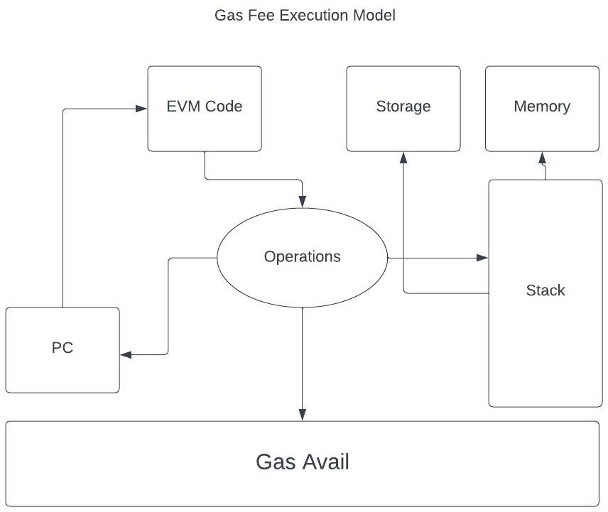

Figure 1. EVM Architecture

This gas fee is paid by the actor who initiates the instruction. This could be the user of our marketplace or our own server according to the design of the application. The figure shows that we follow the architecture that makes the user pay for the transaction just like the industry standard. Ethereum blockchain also has a set amount of fee that is attached to each transaction irrespective of the instructions inside it.

Figure 1 shows how the Ethereum blockchain consisting of an Ethereum Virtual Machine or EVM is responsible for gas fee calculation. The EVM is a completely separate and isolated environment where the Smart contract's instructions can be executed line by line. There are various types of storage or memory that are provided and supported by the EVM. Stack ( used for operation sequencing), Memory ( used for random access ), and Storage( which is used as a persistent memory ). Optimal utilization of these three is required for the least amount of gas fee burn. Certain urgency can also be attached to a transaction which increases the gas fee required to mine it but reduces the time taken by miners to complete it. These factors are taken into account while optimizing the marketplace functions as described in further sections.

1. *NFT Marketplace Architecture*

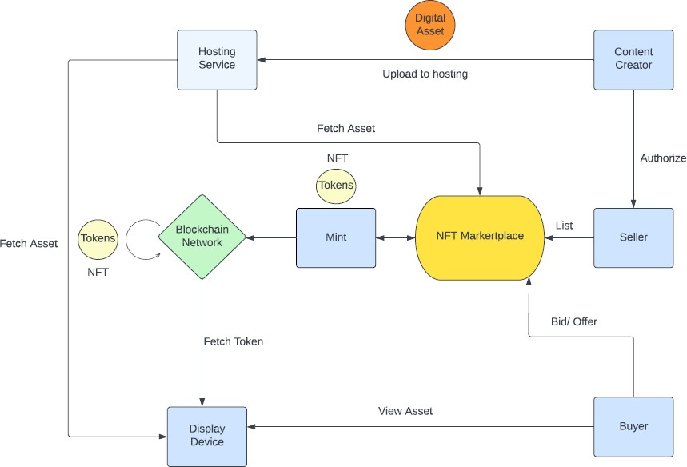

Figure 2. NFT Marketplace Architecture

The marketplace would be an application of smart contract technology of the Ethereum blockchain. Such applications are called dApps or decentralized applications. Figure 2 shows that the dApp would be the layer that interacts with the blockchain and performs stateful actions. A user-facing frontend would be required that allows humans to actually use the marketplace. The user does not interact with the smart contract layer, it uses the frontend interface which communicates to the smart contracts on their behalf. This imitates the client-server model usually followed by traditional web applications.

The following events will be available for users of the marketplace to perform: (a) Authentication and Authorization, (b) Minting, (c) Publishing (d) Trading.

Now each event falls in two categories:

(i) Stateful and ( ii ) Stateless. A stateful event is one that performs a transaction on the blockchain or modifies the actual data by adding another block to the chain. These events modify the chain cost computational power and hence ‘gas’.

Stateless Events only view the current state of the blockchain, they do not perform any modifications to the actual data. These events if also performed on the blockchain cost gas but if performed ‘off-chain’ would be completely free.

Our architecture therefore distinguishes between these events and has events divided into categories like gassy and gasless. Gasless events would require us to maintain a non-blockchain database that writes the event actions without communicating with the actual blockchain. This helps us avoid any additional cost and is thus completely free. Gassy events are traditional blockchain contracts that require computation which is bought in the form of Ethereum gas.

The consistency between these gassy and gasless events has to be maintained otherwise the marketplace would have discrepancies. Therefore we borrow the cryptographic check for on-chain and off chain transactions and apply it to the gassy and gasless events in our architecture.

1. *Optimization*

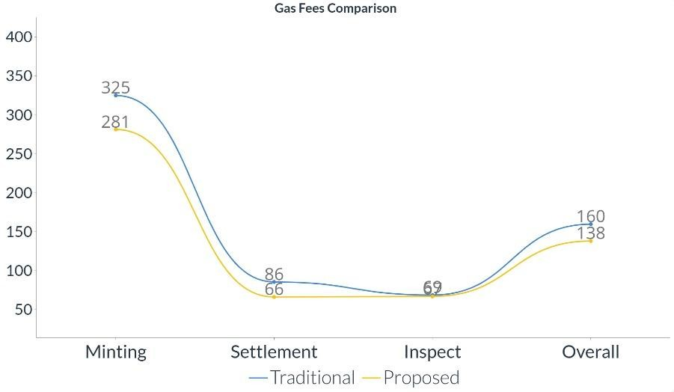

Figure 3. Gas fee comparison

The various techniques employed in the architecture of the marketplace design helped us reduce the gas fees required for certain operations. The approach was to minimize the amount of processing required to complete a transaction. This was achieved by the stateful and stateless paradigm we implemented as described in the above section. The graph shown in Figure 3 represents the different gas fees required for different actions performed. For the y-axis each unit represents 10^3 gwei gas and 1 gwei = 10^-9 eth.

Figure 3 shows how our approach reduces the gas fee required for certain procedures that are necessary for an NFT marketplace.

Table 1. Gas Fee Comparison

|  |  |  |  |
| --- | --- | --- | --- |
| Class | Traditional | Proposed | Saved |
| minting | 325,042 | 281,340 | 43,702 |
| settleme nt | 85,645 | 66,317 | 19328 |
| Inspect | 68,815 | 67,056 | 1759 |

Referring to Table 1 we can observe that the proposed solution can help us save a significant amount of gas fees as compared to the traditional approach. The overall optimization can be estimated to be about 14.7%. This can be significant in terms of large-scale transactions that are executed daily in the massive NFT marketplaces currently being used in the real world.

1. *Implementation*

The application is built using React and the backend using NodeJs. The wallet used for minting NFTs is Metamask. Below are the screens depicting the buy, sell, and minting for the NFTs.

* 1. NFTs Listing screen
  2. Sell an NFT screen
  3. Buy a NFT screen

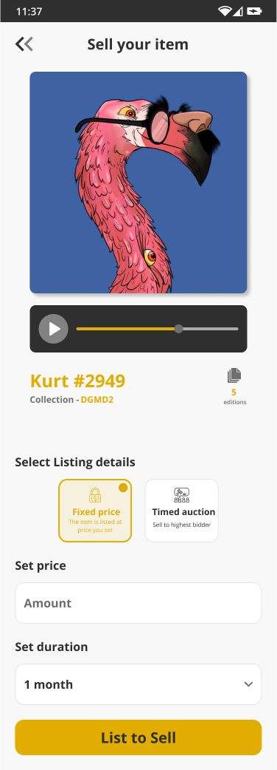

Figure 5. Sell a NFT screen

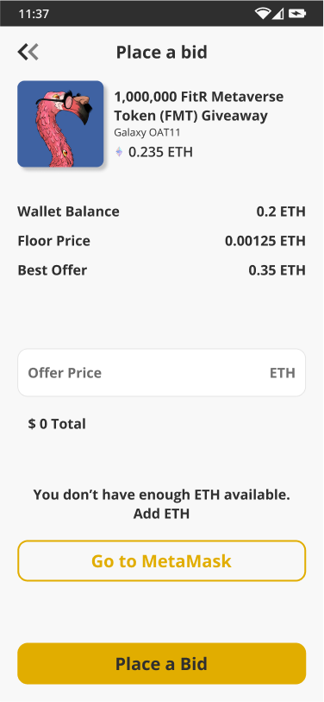

Figure 4. NFTs Listing screen



Figure 6. Buy a NFT screen

Figure 4. shows that the NFTs Listing screen has all the NFTs listed by different users. Different users can place bids on the NFT using cryptocurrencies present in their wallets. The creator can approve the bid and transfer ownership to the bidder.

Figure 5. shows that this screen is a form used by the creator to upload his NFT on the network. NFT can be any type of media file. From the options user can upload NFT at a fixed price or start an auction for it. Users choose the amount and duration that NFT will be present in the marketplace and then can upload it to the Marketplace. After uploading this NFT will be visible to all other users.

Figure 6 shows **that this** page opens up when users select any NFT. It gives details about the available cryptocurrencies on the user’s wallet and the initial and current bid for that NFT. By placing a bid, if the user's bid is matched the amount will be deducted from its wallet and the user will get the ownership of that NFT.

# CONCLUSION

To conclude, using the two-state approach and the stateless paradigm we reduce the amount of gas fees required by 14.7%. This enables the NFT marketplaces to be more scalable and also save money which would otherwise be wasted away in extra computation and mining.NFTs are secured using blockchain technology, which ensures their authenticity and scarcity, making them valuable and collectible. The NFT ecosystem is rapidly growing, with agrowing number of marketplaces and use cases emerging. However, there are still several challenges and risks associated with NFTs, including security, scalability, and regulation, which will need to be addressed in order to ensure the long-term success and growth of the NFT ecosystem.

NFT opens up a new revenue stream for digital creators, providing them with a new way to monetize their digital creations and showcase their work in a new and exciting way. By using NFTs, digital creators can sell their unique, one-of-a-kind digital assets, such as digital art, music, videos, and others, as well as build a community of fans and collectors around their work.

The Creation of NFT Marketplace takes special attention to creating a user experience for the user and the creator, implementing robust security measures, providing payment options, storage solutions, unique value propositions, partnerships, and complying with all relevant laws and regulations. Overall, NFT marketplaces are an exciting new development in the digital world and are poised to play a significant role in shaping the future of digital ownership and commerce.

# References

1. Akhtar, M. H., Raza, S., & Malik, A.

W. (2021). Understanding Security Issues in the NFT Ecosystem. In 2021 IEEE 3rd International Conference on Computing, Mathematics and Engineering Technologies (iCoMET) (pp. 1-6). IEEE.

1. Nasir, M. (2019). A Survey of Blockchain and Its Evolution. Journal of Information Systems and Technology Management,
2. Kshetri, N., & Voas, J. (2022). A blockchain-based solution for the jewellery industry. Computers & Electrical Engineering,
3. Kshetri, N., & Voas, J. (2021). Metaverse, blockchain, and artificial intelligence. Journal of Intelligent & Fuzzy Systems,
4. "Characterizing Efficiency Optimizations in Solidity Smart Contracts" by T. Brandstätter, S. Schulte, J. Cito and

M. Borkowski (2020).

1. "Design Patterns for Gas Optimization in Ethereum" by L. Marchesi, M. Marchesi, G. Destefanis, G. Barabino and D. Tigano (2020 ).
2. "Research on Smart Contract Optimization Method on Blockchain" by

W. Hu, Z. Fan and Y. Gao (2019).

1. “Computing Exact Worst-Case Gas Consumption for Smart Contracts” Matteo Marescotti , Martin Blicha, Antti E. J. Hyv¨arinen, Sepideh Asadi, and Natasha Sharygina ( 2018 )